#FundChildCare #ChildCareIsEssential Twitter Storm
Wednesday, June 24th at 10:00am

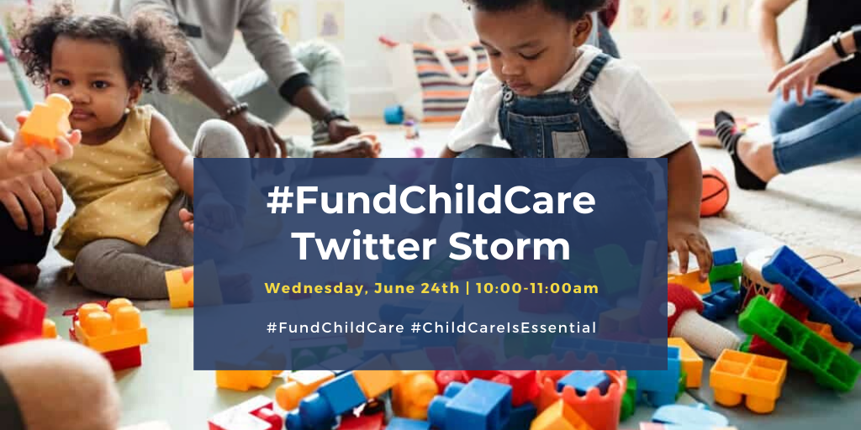

Sample Tweets:

Families rely on our #earlyed system in order to keep working, and our state’s economy does too. #ChildCareIsEssential for NC’s crisis response and recovery. NC can’t go back to work without it. #FundChildCare #COVID19NC #ncga #ncpol
#COVID19NC has underscored that #ChildCareIsEssential. #Essentialworkers are working to keep our communities safe, while #earlyed teachers care for their children, often at risk to their own health and safety. #FundChildCare #ncga #ncpol
1/3 of all #childcare programs in the state are still closed. Many may not ever reopen, making it incredibly hard for NC’s families to go back to work when the #COVID19NC crisis is over. #FundChildCare #ChildCareIsEssential #ncga #ncpol
#Childcare teachers are risking their own health to care for children during #COVID19NC. Yet many have no health insurance or sick leave and earn an average of $10.50/hour. It’s time to support the workforce behind the workforce. #FundChildCare #ChildCareIsEssential #ncga #ncpol
Without state support for our critical #earlyed infrastructure, NC’s families and economy will struggle to recover. Parents need reliable, high-quality #childcare in order to be able to return to work. #FundChildCare #ChildCareIsEssential #COVID19NC #ncga #ncpol
#ECE programs operate on very thin margins even in a strong economy. The #childcare sector needs significant financial support to reopen their doors in order to be there for NC’s families when this is over. #FundChildCare #ChildCareIsEssential #COVID19NC #ncga #ncpol
Many #childcare programs don’t have funding for #PPE and cleaning supplies needed to protect the health of their staff and the families they serve. It’s time to #FundChildCare and treat them like the #essentialworkers they are. #ChildCareIsEssential #ncga #ncpol
It’s critical that #ncga policymakers provide additional #childcare relief funding so providers will be there now and in the future for NC’s families. #FundChildCare #ChildCareIsEssential #COVID19NC #ncpol
NC needs its #earlyed system in place to enable parents to go back to work, businesses to open, and the economy to recover. We have to #FundChildCare now to give #childcare providers the support they need to weather the storm. #ChildCareIsEssential #COVID19NC #ncga #ncpol
Sharegraphics:
